

Data Technician

Name:
Course Date:
Table of contents
Day 1: Task 1 2
Day 1: Task 2 2
Day 2: Task 1 3
Day 2: Task 2 3
Day 3: Task 1 4
Day 3: Task 2 5
Day 4: Task 1 6
Day 4: Task 2 7
Course Notes 7
Additional Information 8

Day 1: Task 1

Please research the different versions of Tableau, compare and contrast them below and explain the limited functionality on ‘Tableau Public’.

Different Tableau versions | Tableau offers several versions — Desktop, Server, Cloud (formerly Online), Reader, and Public. Tableau Public is the free edition but has major limitations: all workbooks are saved publicly online, limited data source connections, no local saving, and restricted row capacity. It’s excellent for learning and sharing public data stories but unsuitable for private or enterprise use.

Day 1: Task 2

Using the EMSI_JobChange_UK dataset, create your own dashboard, I want to see a bar chart showing percentage change and a UK based map showing the key city locations impacted.

Paste your print screen here | 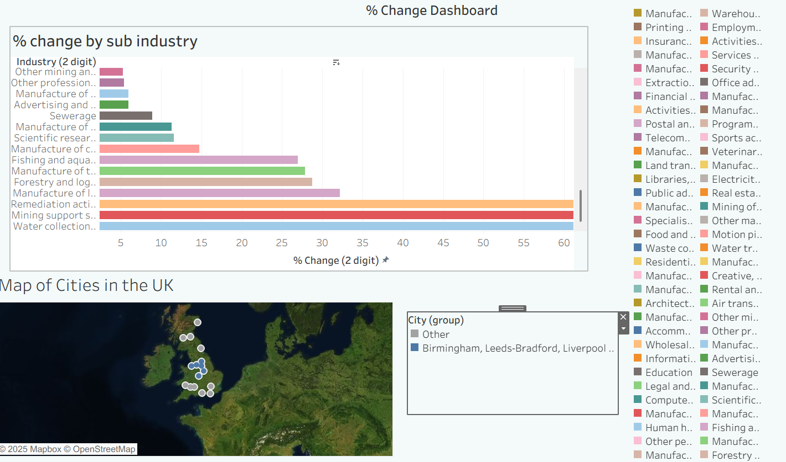

Day 2: Task 1

Using the Spotify data set, conduct an analysis to find trends and key information that could be used by an organisation for future projects.

There is no set scope for the analysis, simply to find trends and document them below:

Paste your print screens here | 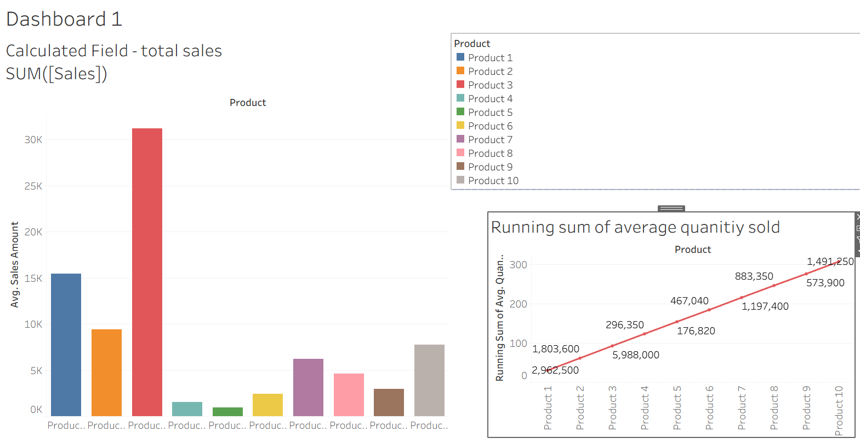  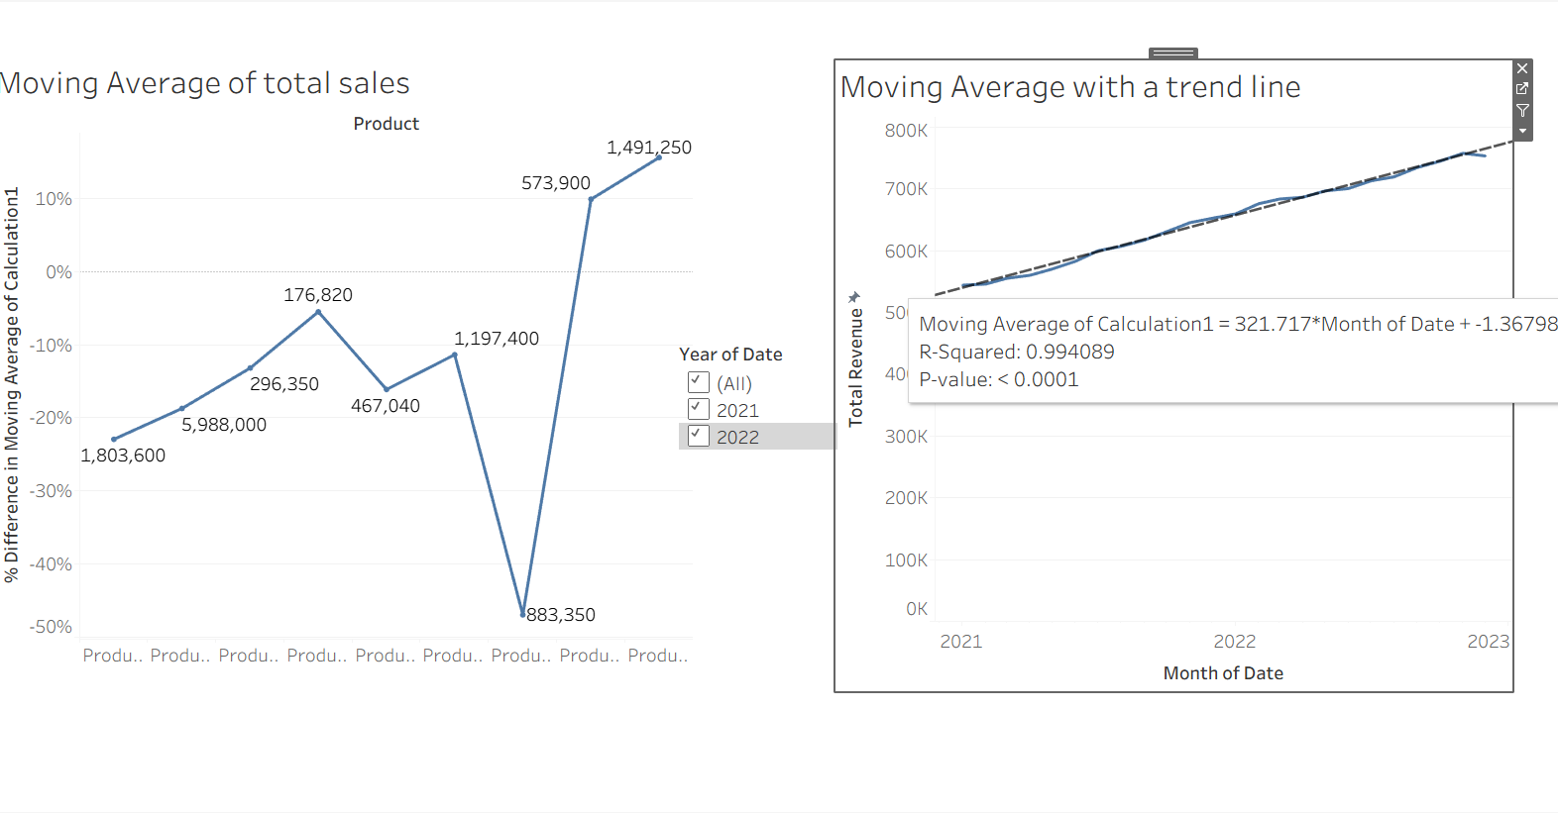  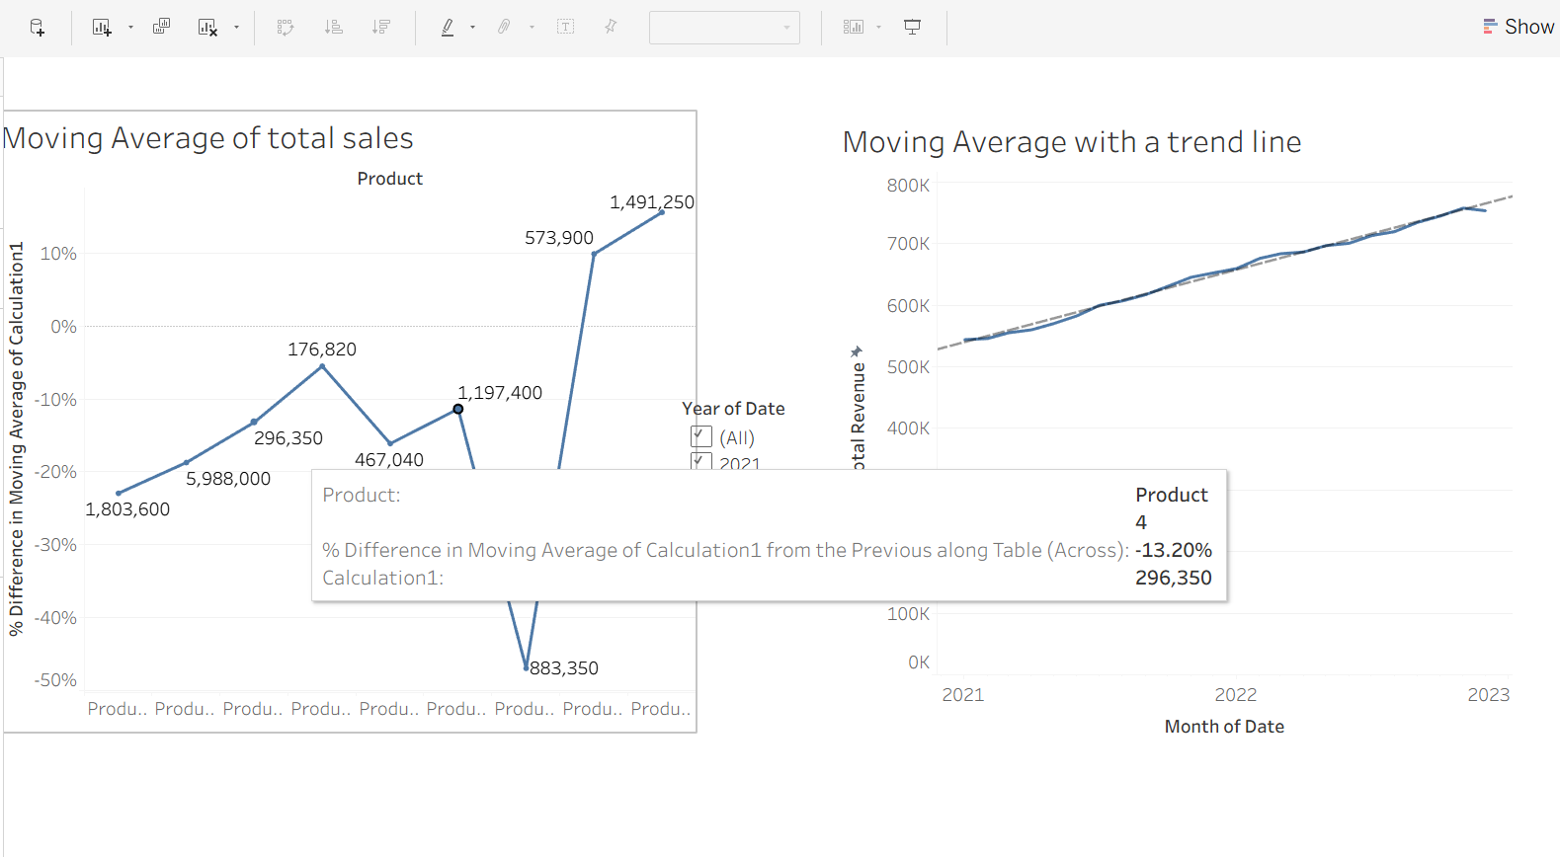

What did you find? | The top dashboard shows sales performance for ten products with two charts:Bar Chart: Average Sales by Product: Product 2 leads in average sales, followed by Products 1 and 3.Products 4 to 10 have much lower sales.  Line Chart: Running Sum of Average Quantity Sold  Starts at 1,803,600 for Product 1 and rises steadily to 7,205,400 by Product 10.Illustrates each product's incremental contribution to total quantity sold.  Legend:Top-right, colors identify each product.  This dashboard helps spot top products by sales and quantity, guiding inventory and marketing decisions  The lower two charts provide a time-based analysis of sales performance using moving averages and trend lines, which help smooth out fluctuations and reveal underlying patterns.  Left Chart: Moving Average of Total Sales by Product Category  Purpose: Compares the moving average of total sales across different product categories over three years (2021–2023).  X-axis: Product categories Y-axis: Difference in moving average of total sales (Calculation1).  You can see how each product category performed over time.Categories with values like 1,803,600 and 1,491,250 likely represent top performers.The year-over-year comparison helps identify trends or shifts in category performance.  Right Chart: Moving Average with Trend Line Over Time  Purpose is to Tracks total revenue over time (by month) and fits a trend line to the moving average.  X-axis: Month of Date.Y-axis: Total Revenue.  The moving average smooths monthly revenue to highlight consistent trends.  The trend line shows a strong upward trajectory, supported by:  - R² = 0.994, indicating a very strong fit.  - P-value < 0.0001, meaning the trend is statistically significant.  Tooltip shows a moving average value of 321,717, suggesting steady monthly revenue.

Day 2: Task 2

Using the Health, conduct an analysis to find trends and key information that could be used by an organisation for future support.

There is no set scope for the analysis, simply to find trends and document them below.

- Data can be lifesaving and is being used more within the NHS, reflect on how this data could support decision making for the NHS.

Paste your print screens here | 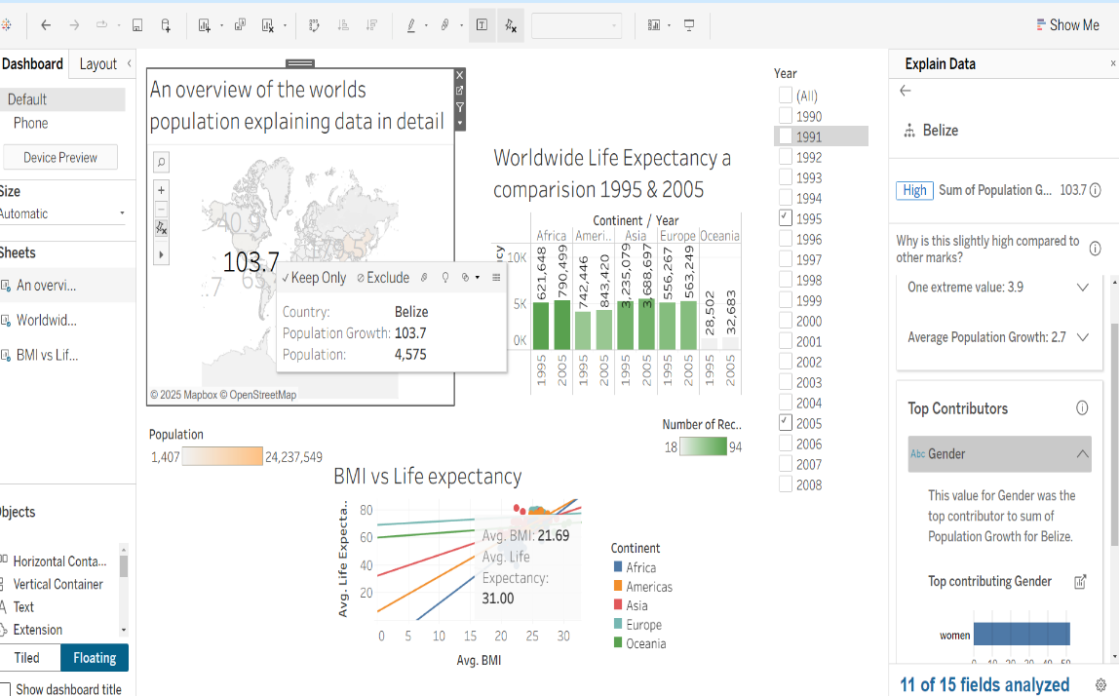  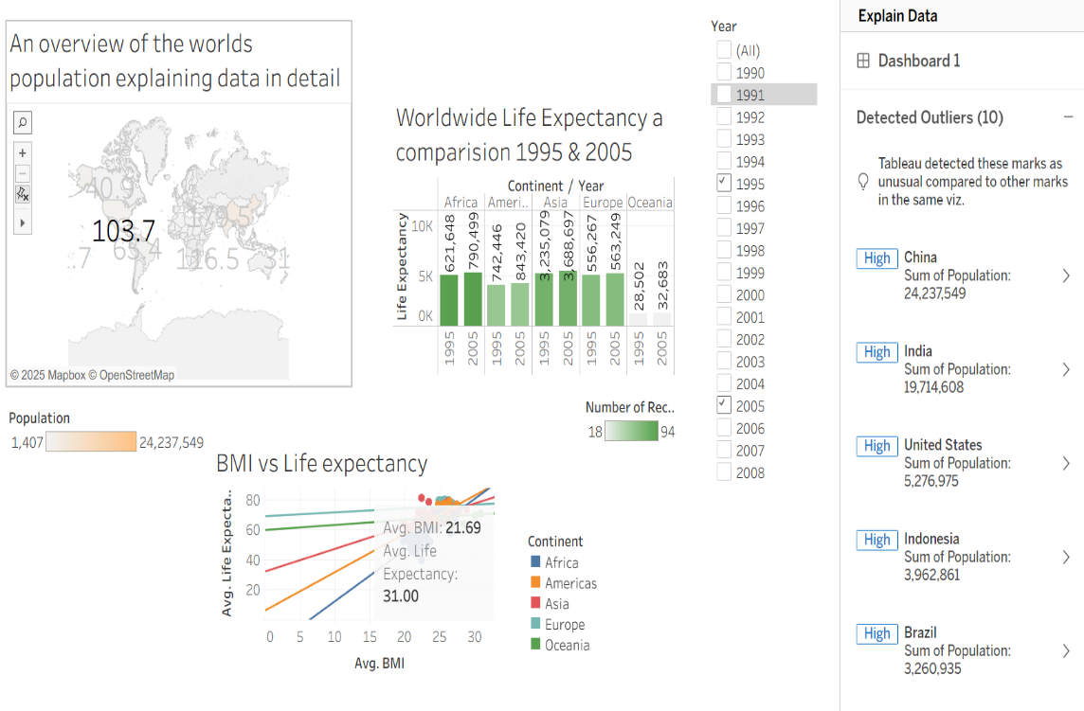  Life Expectancy Trends: All continents improved from 1995 to 2005. Europe and Oceania lead; Africa lags behind.  BMI vs Life Expectancy: Moderate BMI (like Europe’s 25.55) aligns with highest life expectancy. Very low (Africa) and very high (Oceania) BMIs correlate with lower longevity.  Outliers: China, India, USA, Indonesia, and Brazil have unusually high population totals, influencing global averages.  Overall: The dashboard highlights global health disparities, progress over time, and the complex link between nutrition and lifespan.  The NHS could use this information to complete the following
What did you find and any reflections on how the NHS could use this? | Targeted Public Health Campaigns: Use BMI vs life expectancy data to tailor nutrition and lifestyle interventions by region or demographic.  Benchmarking & Policy Planning: Compare UK life expectancy trends with global data to identify areas for improvement and set realistic health targets.  Resource Allocation: Prioritize funding and services in regions with lower life expectancy or rising BMI to prevent long-term health issues.  Predictive Analytics: Monitor outlier countries (e.g., high population impact) to anticipate global health trends that may affect the UK.  Health Equity Focus: Highlight disparities (like Africa’s lower life expectancy) to inform international aid or migrant health support strategies.

Day 3: Task 1

Please complete Lab 1 ‘Get Data in Power Bi Desktop’. Once complete, paste a print screen below and in the collaboration board.

“Teaching is the best way to learn, so please listen out for support requests from the class and we’ll work through the challenges together”

Paste your completed lab here | 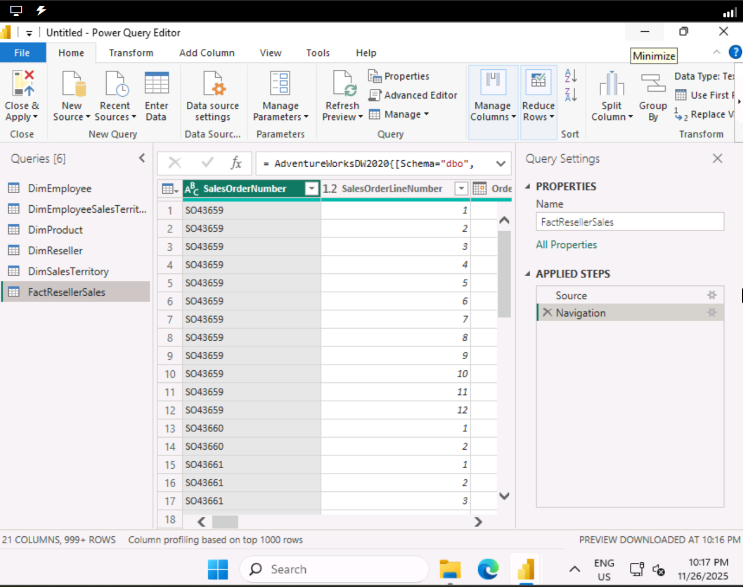

Day 3: Task 2

Please complete Lab 2 ‘Load Transformed Data in Power BI Desktop’. Once complete, paste a print screen below and in the collaboration board.

“Teaching is the best way to learn, so please listen out for support requests from the class and we’ll work through the challenges together”

Paste your completed lab here | 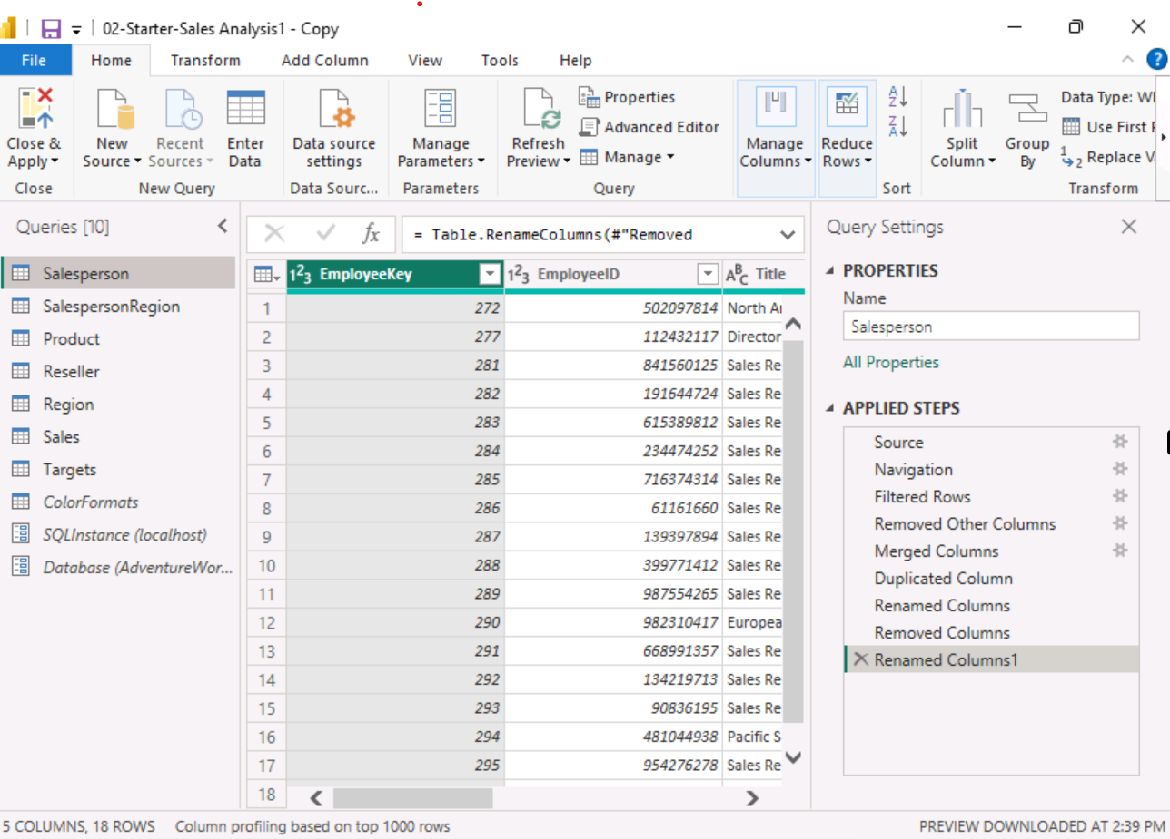

Day 4: Task 1

Please complete Lab 8 ‘Design a Report in Power BI Desktop’. Once complete, paste a print screen below and in the collaboration board.

“Teaching is the best way to learn, so please listen out for support requests from the class and we’ll work through the challenges together”
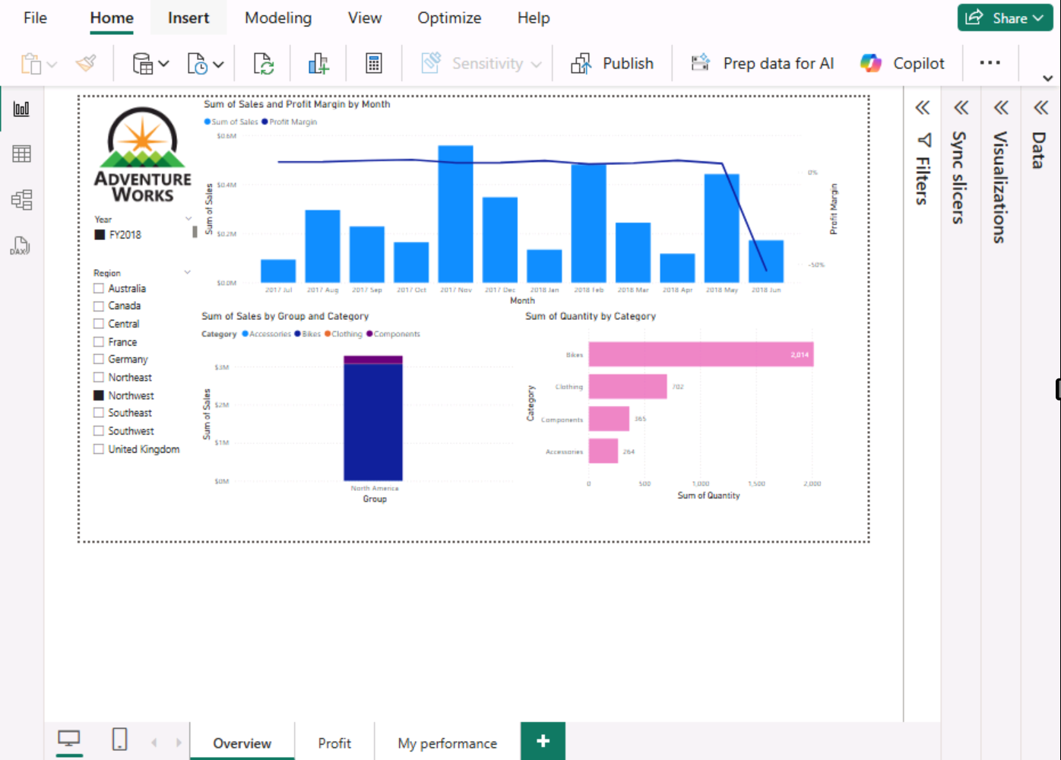
Paste your completed lab here | 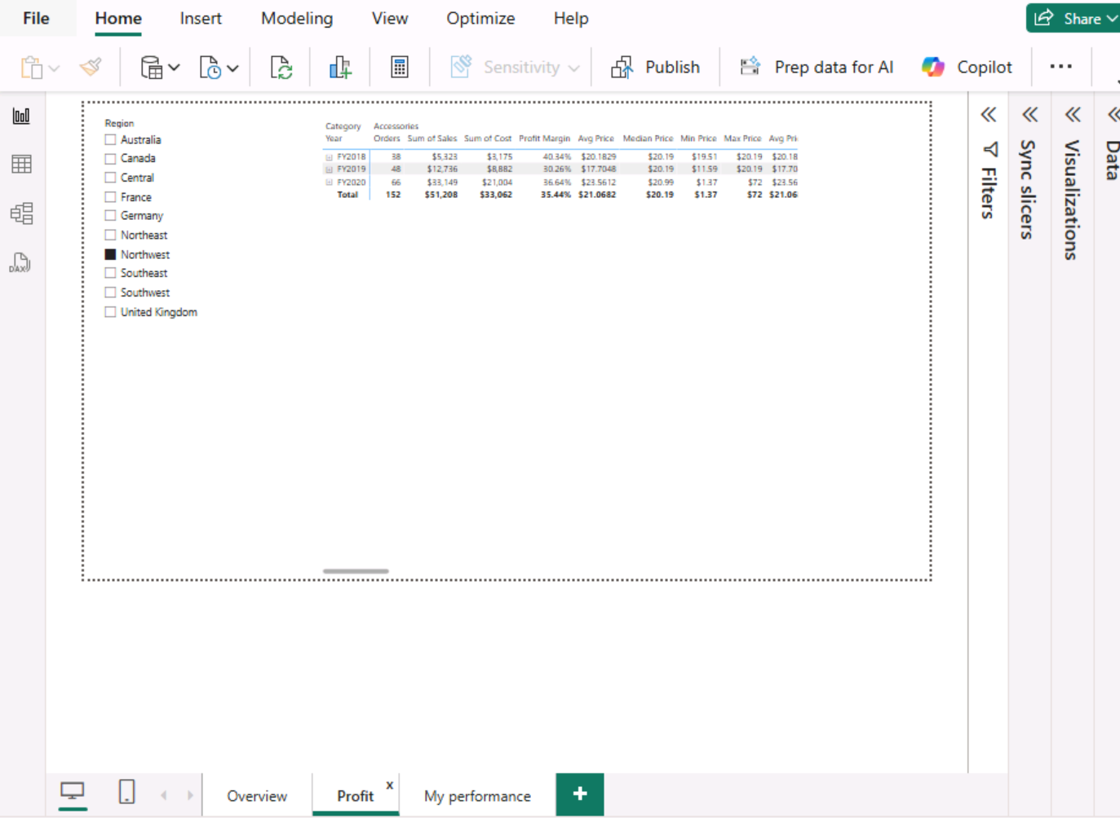  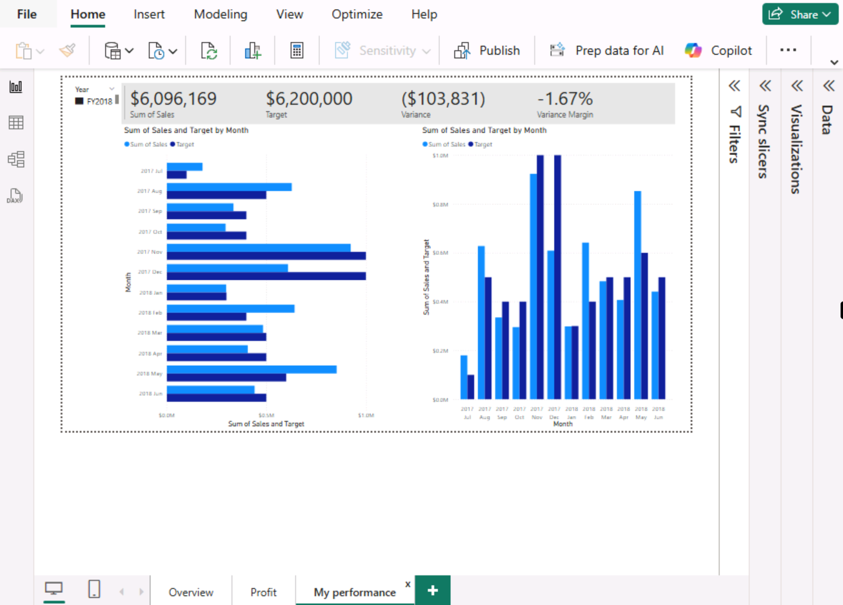

Day 4: Task 2

Please complete Lab 12 ‘Create a Power BI Dashboard’. Once complete, paste a print screen below and in the collaboration board.

“Teaching is the best way to learn, so please listen out for support requests from the class and we’ll work through the challenges together”

Paste your completed lab here | 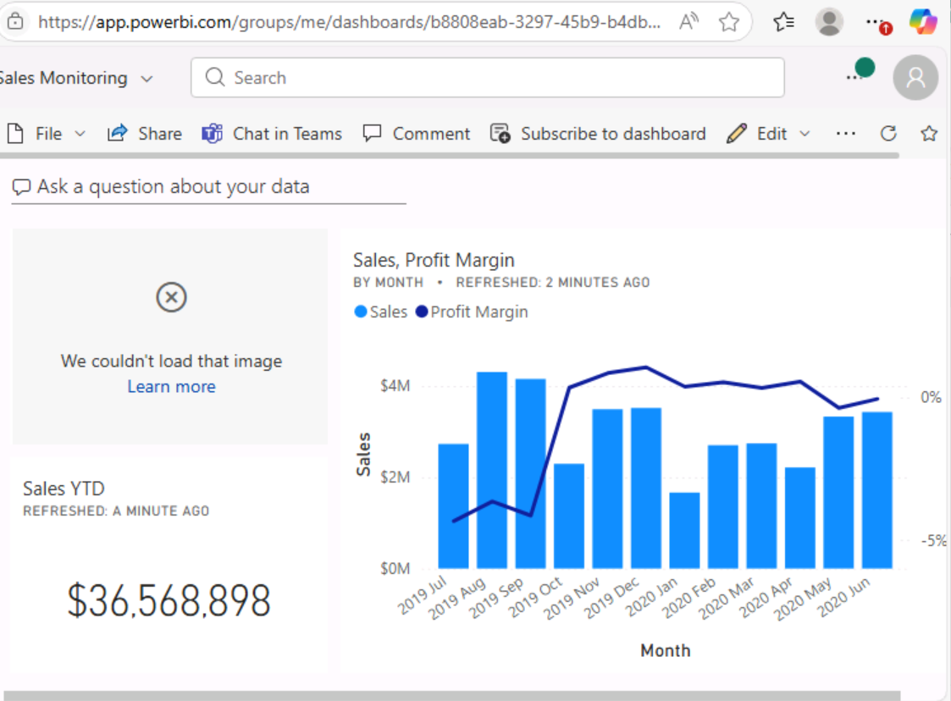  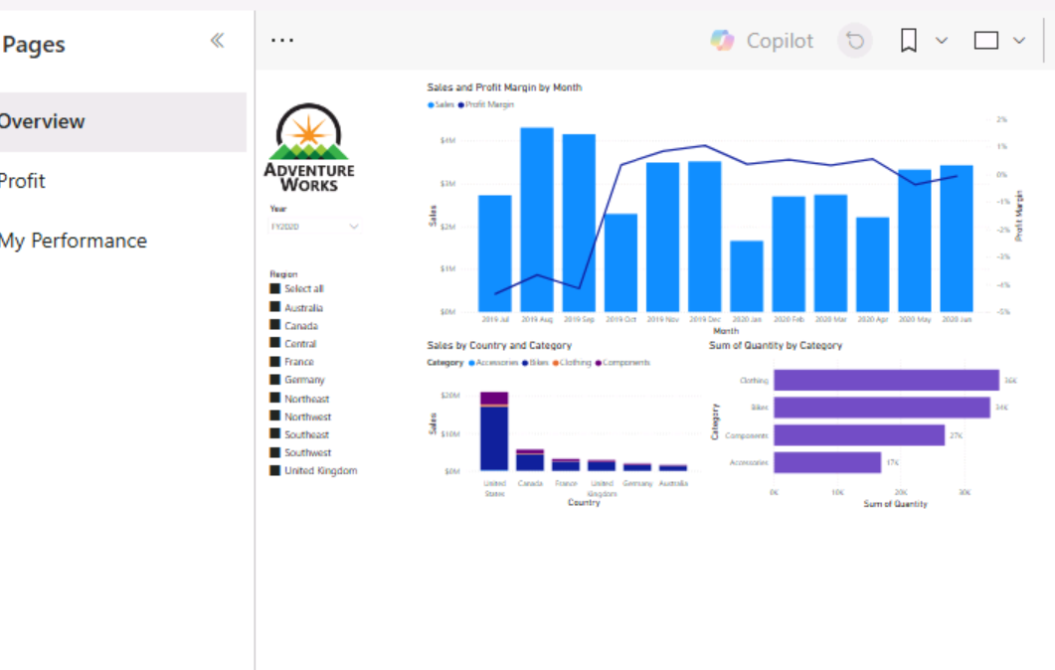

Course Notes

It is recommended to take notes from the course, use the space below to do so, or use the revision guide shared with the class.

We have included a range of additional links to further resources and information that you may find useful, these can be found within your revision guide.

END OF WORKBOOK

Please check through your work thoroughly before submitting and update the table of contents if required.

Please send your completed work booklet to your trainer.

Information

